

JAVA PROJECT REPORT ON

SALARY PAYROLL PROCESSING AND PAYSLIP
GENERATION SYSTEM
Submitted by
DHAKSHANA K
25BCS015

Under the Guidance of
Dr. BOOPALAN SUNDARAMOORTHY
Technical Trainer
Technical Department, KG College of Arts and Science

Academic Year: 2025 – 2026
APRIL 2026
Semester: II

DECLARATION
I hereby declare that the project entitled “SALARY PAYROLL PROCESSING AND PAYSLIP GENERATION SYSTEM” submitted in partial fulfillment of the requirements for the course [JAVA PROGRAMMING LANGUAGE] is a record of my original work carried out under the guidance of [Dr. BOOPALAN SUNDARAMOORTHY], Technical Trainer, Technical Department, KG College of Arts and Science.
I further declare that this project has not been submitted previously, either in part or in full, for the award of any degree, diploma, or other similar title, at this or any other institution.
I have acknowledged all sources of information used in this project wherever applicable.

April 2026
Coimbatore

DHAKSHANA K ________________________
(Your Name)

CERTIFICATE
This is to certify that the project entitled “SALARY PAYROLL PROCESSING AND PAYSLIP GENERATION SYSTEM” is a bona fide work carried out by [DHAKSHANA K] [I – A/2025 - 2028], [COMPUTER SCIENCE], KG College of Arts & Science, in partial fulfillment of the requirements for the course [JAVA PROGRAMMING LANGUAGE].
This project has been completed under my supervision and guidance during the academic period April 2026.

Place: Coimbatore
Date: 10/04/2026

Submitted for the Viva-Voce Examination held on 10/04/2026

Guide: Head of the Department
(Technical Trainer, KGCAS) (Technical Head, KGCAS)

______________________ _______________________

TABLE OF CONTENTS
S. No. | Topics | Page. No.
1 | Introduction
1.1 | Objective
1.2 | Overview
1.3 | Features
2 | Program Analysis
2.1 | Problem Definition
2.2 | Project Overview
2.3 | Scopes and Limitations
3 | System Design
3.1 | Modules
4 | Methodology
4.1 | Problem Analysis
4.2 | System Design
4.3 | Program Development
4.4 | Testing and Validation
4.5 | Result and Documentation
4.6 | Algorithm
4.7 | Flowchart
5 | Source Code
6 | Input and Output Screens
7 | Discussion and Conclusion
7.1 | Discussion
7.2 | Conclusion
8 | References

ABSTRACT
The Salary Payroll Processing and Payslip Generation System is a Java-based application developed to automate the process of employee salary management in organizations. In many small and medium-sized businesses, payroll processing is often carried out manually, which can lead to calculation errors, delays, and inefficient record handling.
This project aims to simplify payroll operations by providing an automated system that calculates employee salaries based on basic pay, allowances, and deductions such as tax and provident fund. The system generates a structured payslip that clearly displays salary details including gross salary, total deductions, and net salary.
The application is developed using Core Java programming concepts such as classes, objects, methods, loops, and conditional statements. It can be implemented as a console-based application or extended to a graphical user interface using Java Swing.
The main objective of this system is to improve accuracy, reduce manual effort, and provide a fast and reliable payroll solution. The system ensures error-free salary computation and generates clear payslips for employees.
This project demonstrates the practical application of Java programming in solving real-world problems related to payroll management and serves as a foundation for developing advanced payroll systems in the future.

1. INTRODUCTION
Payroll management is an essential function in every organization, as it involves the calculation and distribution of employee salaries. In many small and medium-scale businesses, payroll processing is still performed manually using paper records or spreadsheets. This traditional approach is time-consuming, prone to errors, and difficult to manage, especially when dealing with multiple employees.
Manual payroll systems often lead to incorrect salary calculations, delays in payment, and improper handling of employee records. These issues can result in employee dissatisfaction and reduced organizational efficiency. Therefore, there is a need for an automated system that can handle payroll operations accurately and efficiently.
The Salary Payroll Processing and Payslip Generation System is a Java-based application designed to automate salary calculations and generate payslips. The system allows the user to enter employee details such as name, ID, and basic salary. It automatically calculates allowances like House Rent Allowance (HRA) and Dearness Allowance (DA), as well as deductions such as tax and provident fund (PF), to determine the net salary.
The system generates a clear and structured payslip that includes all relevant salary details such as earnings, deductions, gross salary, and net salary. This helps in maintaining transparency and accuracy in payroll processing.
This project is developed using Core Java programming concepts such as classes, objects, methods, loops, and conditional statements. The application can be implemented as a console-based program or enhanced with a graphical user interface using Java Swing.
The main goal of this system is to reduce manual effort, improve accuracy, and provide a reliable payroll solution. It also demonstrates how Java programming can be applied to develop practical real-world business applications.
1.1 Objective
The main objective of the Salary Payroll Processing and Payslip Generation System is to develop a simple and efficient payroll application using Core Java that automates salary calculation and payslip generation.
The specific objectives are:
• To design and develop a Java-based payroll system
• To automate salary calculations
• To reduce manual errors in payroll processing
• To generate accurate and structured payslips
• To provide a user-friendly interface
• To demonstrate Core Java programming concepts
1.2 Overview
The system is a menu-driven application developed using Java programming language. It provides a digital platform where users can enter employee details and generate payslips automatically.
The system calculates salary components such as allowances and deductions based on the basic salary entered by the user. It then generates the final payslip showing gross salary, deductions, and net salary.
This system simplifies payroll processing by eliminating manual calculations and improving efficiency. It can be developed as a console-based application or extended to a graphical user interface.
1.3 Features
The Salary Payroll Processing and Payslip Generation System includes the following features:
• Employee Details Entry – Allows user to input employee information
• Salary Calculation – Calculates allowances such as HRA and DA
• Deduction Calculation – Computes tax and provident fund
• Payslip Generation – Generates a detailed salary slip
• User-Friendly Interface – Easy to use system
• Fast Processing – Reduces time required for payroll tasks

2. PROGRAM ANALYSIS

Program analysis is an important phase in software development where the problem is studied in detail and system requirements are identified. This phase helps in understanding how the system should function and what features are needed to solve the problem effectively.
In the case of the Salary Payroll Processing and Payslip Generation System, the analysis focuses on identifying the issues in the existing manual payroll system and proposing an automated solution to improve efficiency, accuracy, and record management.
2.1 Problem Definition
In many small organizations and businesses, employee salary processing is done manually using paper records or spreadsheets. This traditional method creates several challenges.
Some common problems include:
• Errors in salary calculation
• Time-consuming payroll processing
• Difficulty in managing multiple employee records
• Incorrect deduction calculations (tax, PF, etc.)
• Lack of proper payslip generation
• Poor data management and record keeping
Manual systems increase workload and may lead to employee dissatisfaction due to incorrect salary or delays.
Therefore, there is a need for an automated payroll system that can efficiently calculate salaries, manage employee data, and generate accurate payslips.
The Salary Payroll Processing and Payslip Generation System is designed to solve these issues by providing a computerized solution.
2.2 Project Overview
The Salary Payroll Processing and Payslip Generation System is a Java-based application developed to automate salary processing in an organization.
The system provides a simple interface where users can:
• Enter employee details (Name, ID, Basic Salary)
• Calculate allowances such as HRA and DA
• Calculate deductions such as Tax and Provident Fund
• Generate net salary automatically
• Produce a structured payslip
The system performs all calculations automatically and displays the final salary details clearly.
This project is implemented using Core Java programming concepts and can be developed as a console-based application or with a graphical interface using Java Swing.
2.3 Scopes and Limitations
Scope
The scope of the system includes:
• Managing employee salary details
• Automating payroll calculations
• Generating employee payslips
• Reducing manual effort and errors
• Demonstrating Core Java concepts
The system can be used in:
• Small companies
• Offices
• Educational institutions
• Shops and small businesses
Limitations
• Does not store data permanently (without database integration)
• Limited to basic payroll calculations
• Not suitable for large-scale enterprise use
• No advanced features like online payment or cloud storage

3. SYSTEM DESIGN

System design is the stage where the structure and components of the system are planned before implementation. In this phase, the system is divided into different modules, and the workflow is clearly defined. A good system design makes the program easy to develop, understand, and maintain.
The Salary Payroll Processing and Payslip Generation System is designed as a user-friendly application where users can enter employee details, calculate salary components, and generate payslips automatically.
The system is divided into several modules, each responsible for a specific function.

3.1 Modules
The main modules of the Salary Payroll Processing and Payslip Generation System are explained below:
1. Employee Details Module
This module is responsible for collecting and storing employee information.
Functions of this module include:
• Accepting employee name
• Accepting employee ID
• Accepting basic salary
Example:
Employee Name: John
Employee ID: 101
Basic Salary: ₹20,000
This module acts as the input stage for the system.
2. Salary Calculation Module
This module calculates the earnings of the employee based on the basic salary.
The system calculates:
• HRA (House Rent Allowance) – e.g., 20% of basic salary
• DA (Dearness Allowance) – e.g., 10% of basic salary
• Gross Salary = Basic Salary + HRA + DA
Example Calculation:
HRA = 20% of 20,000 = 4,000
DA = 10% of 20,000 = 2,000
Gross Salary = 26,000
3. Deduction Module
This module calculates the deductions from the salary.
Deductions include:
• Tax (e.g., 5% of gross salary)
• Provident Fund (PF) (e.g., 2% of gross salary)
Example:
Tax = 5% of 26,000 = 1,300
PF = 2% of 26,000 = 520
Total Deduction = 1,820
4. Net Salary Calculation Module
This module calculates the final salary after deductions.
Formula:
Net Salary = Gross Salary – Total Deductions
Example:
Net Salary = 26,000 – 1,820 = 24,180
5. Payslip Generation Module
This module generates the final payslip for the employee.
The payslip includes:
• Employee Name
• Employee ID
• Basic Salary
• Allowances (HRA, DA)
• Gross Salary
• Deductions (Tax, PF)
• Net Salary
Example Output:

------ PAYSLIP ------

Employee Name: John
Employee ID: 101

Basic Salary: 20000
HRA: 4000
DA: 2000

Gross Salary: 26000

Tax: 1300
PF: 520

Net Salary: 24180

---------------------
6. Exit Module
This module allows the user to safely exit the application.
When selected, the system terminates the program.

4. METHODOLOGY
Methodology describes the process followed to develop the project. It explains the steps taken from understanding the problem to designing, implementing, testing, and documenting the system.
For the Salary Payroll Processing and Payslip Generation System, a structured development approach was followed to ensure that the system meets requirements and works efficiently.
The development process includes the following stages:
• Problem Analysis
• System Design
• Program Development
• Testing and Validation
• Result and Documentation
4.1. Problem Analysis
In this phase, the existing manual payroll system is studied and analyzed in detail.
The main problems identified are:
• Manual salary calculation may lead to errors
• Payroll processing takes more time
• Difficult to manage multiple employees
• Incorrect deductions and calculations
• Lack of proper payslip generation
Based on these problems, the system requirements were defined to develop an automated payroll system that simplifies salary processing and improves accuracy.
4.2. System Design
In this stage, the structure of the system is planned before coding begins.
The system is divided into modules such as:
• Employee Details Module
• Salary Calculation Module
• Deduction Module
• Net Salary Module
• Payslip Generation Module
• Exit Module
The design ensures that users can easily interact with the system and generate payslips efficiently.
4.3. Program Development
After designing the system, the program is implemented using Java programming language.
The following steps were followed:
• Creation of classes and objects
• Writing methods for salary calculations
• Implementing logic for allowances and deductions
• Accepting user input
• Displaying the final payslip
Core Java concepts such as loops, conditional statements, methods, and object-oriented programming were used.
4.4. Testing and Validation
Testing ensures that the program works correctly and produces the expected results.
Different test cases were used to check the functionality of the system.
Example Test Cases:

Test Case | Expected Result
Enter employee details | Accepted correctly
Calculate salary | Correct output
Apply deductions | Accurate deduction
Generate payslip | Proper display
Invalid input | Error handled
This phase ensures the system is reliable and error-free.
4.5. Result and Documentation
After successful testing, the results are documented.
The system generates:
• Accurate salary calculations
• Proper deduction details
• Clear payslip output
Screenshots and outputs are included to demonstrate system functionality.
4.6. Algorithm
Algorithm for Salary Payroll Processing System:
1. Start the program
2. Enter employee details
3. Input basic salary
4. Calculate HRA and DA
5. Calculate gross salary
6. Calculate tax and PF
7. Calculate total deductions
8. Compute net salary
9. Display payslip
10. End the program
4.7. Flowchart
Students should draw a flowchart showing program flow.
Example flow:
Start
↓
Enter Employee Details
↓
Calculate Salary
↓
Apply Deductions
↓
Generate Payslip
↓
End
Students can draw using:
- draw.io
- Lucidchart
- MS Visio

5. SOURCE CODE

Include important parts of the Java code such as:
- Main class
public class Main {
public static void main(String[] args) {
PayrollSystem obj = new PayrollSystem();
obj.generatePayslip("John", 101, 20000)
}
}
- Menu logic
public class Main {
public static void main(String[] args) {

PayrollSystem obj = new PayrollSystem();
obj.generatePayslip("John", 101, 20000);

}
}
- Salary Calculation
double hra = basic * 0.20;
double da = basic * 0.10;

double gross = basic + hra + da;

double tax = gross * 0.05;
double pf = gross * 0.02;

double netSalary = gross - (tax + pf);
- Payslip Generation Method
public void generatePayslip(String name, int id, double basic) {

double hra = basic * 0.20;
double da = basic * 0.10;
double gross = basic + hra + da;

double tax = gross * 0.05;
double pf = gross * 0.02;

double netSalary = gross - (tax + pf);

System.out.println("----- PAYSLIP -----");
System.out.println("Name: " + name);
System.out.println("ID: " + id);
System.out.println("Net Salary: " + netSalary);
}

6. INPUT AND OUTPUT SCREENS

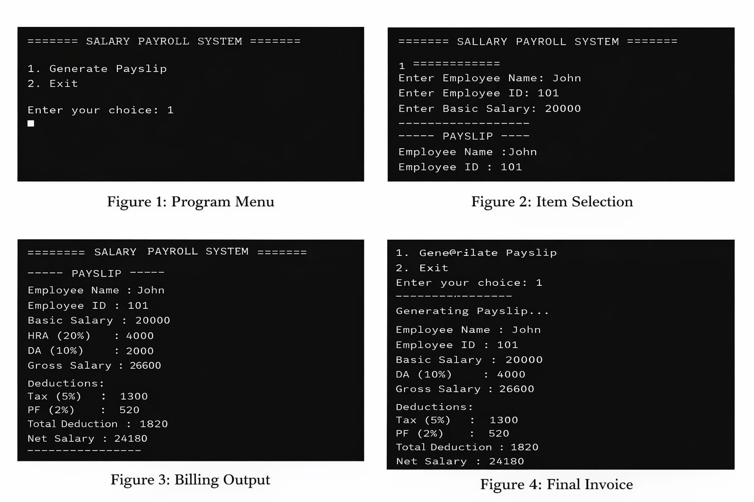

7. DISCUSSION & CONCLUSION

7.1 Discussion
The Salary Payroll Processing and Payslip Generation System was developed to automate the process of employee salary calculation and payslip generation. The system allows users to enter employee details, calculate salary components such as allowances and deductions, and generate a structured payslip.
During the development of this project, Core Java programming concepts such as classes, objects, methods, loops, and conditional statements were applied effectively. The system performs accurate calculations for gross salary, deductions like tax and provident fund, and net salary.
The application was tested with different inputs to ensure correctness and reliability. The results show that the system reduces manual effort, minimizes calculation errors, and improves efficiency in payroll processing.
The system provides a simple and user-friendly interface, making it easy for users to operate even with basic computer knowledge.

7.2 Conclusion
The Salary Payroll Processing and Payslip Generation System successfully demonstrates the implementation of Core Java concepts in developing a real-world application.
The system automates salary processing, reduces human errors, and generates accurate payslips efficiently. It simplifies payroll management and saves time compared to manual methods.
This project helps in understanding how programming can be used to solve practical problems in organizations. It can be further enhanced by adding features such as database integration, graphical user interface (GUI), multi-user access, and online payroll management.
Overall, the project achieves its objective of creating a simple, efficient, and reliable payroll system.

8. REFERENCES

The following resources were used during the development of this project:
Books
• Herbert Schildt – Java: The Complete Reference
• E. Balagurusamy – Programming with Java
• Y. Daniel Liang – Introduction to Java Programming
Websites
• https://www.oracle.com/java⁠
• https://www.geeksforgeeks.org⁠
• https://www.w3schools.com
• https://www.javatpoint.com⁠
• https://stackoverflow.com⁠

